INSTRUCTIONS FOR YEAR 11 – HIGHER
LESSON ONE
STEP 1: Click on the link below to take you to the webpage.
Year 11 Maths Higher
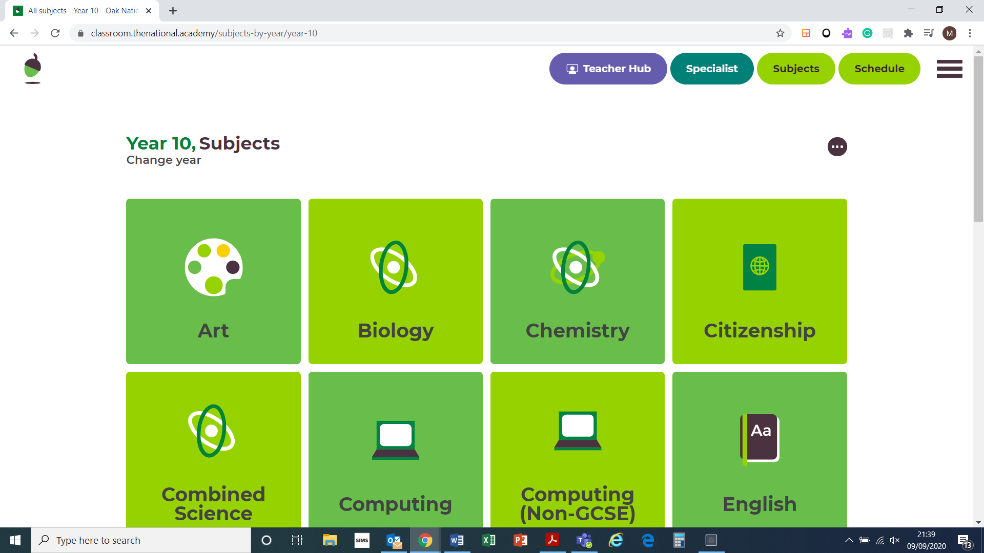

STEP 3: Scroll down to ‘Trigonometry 1 and click on it.
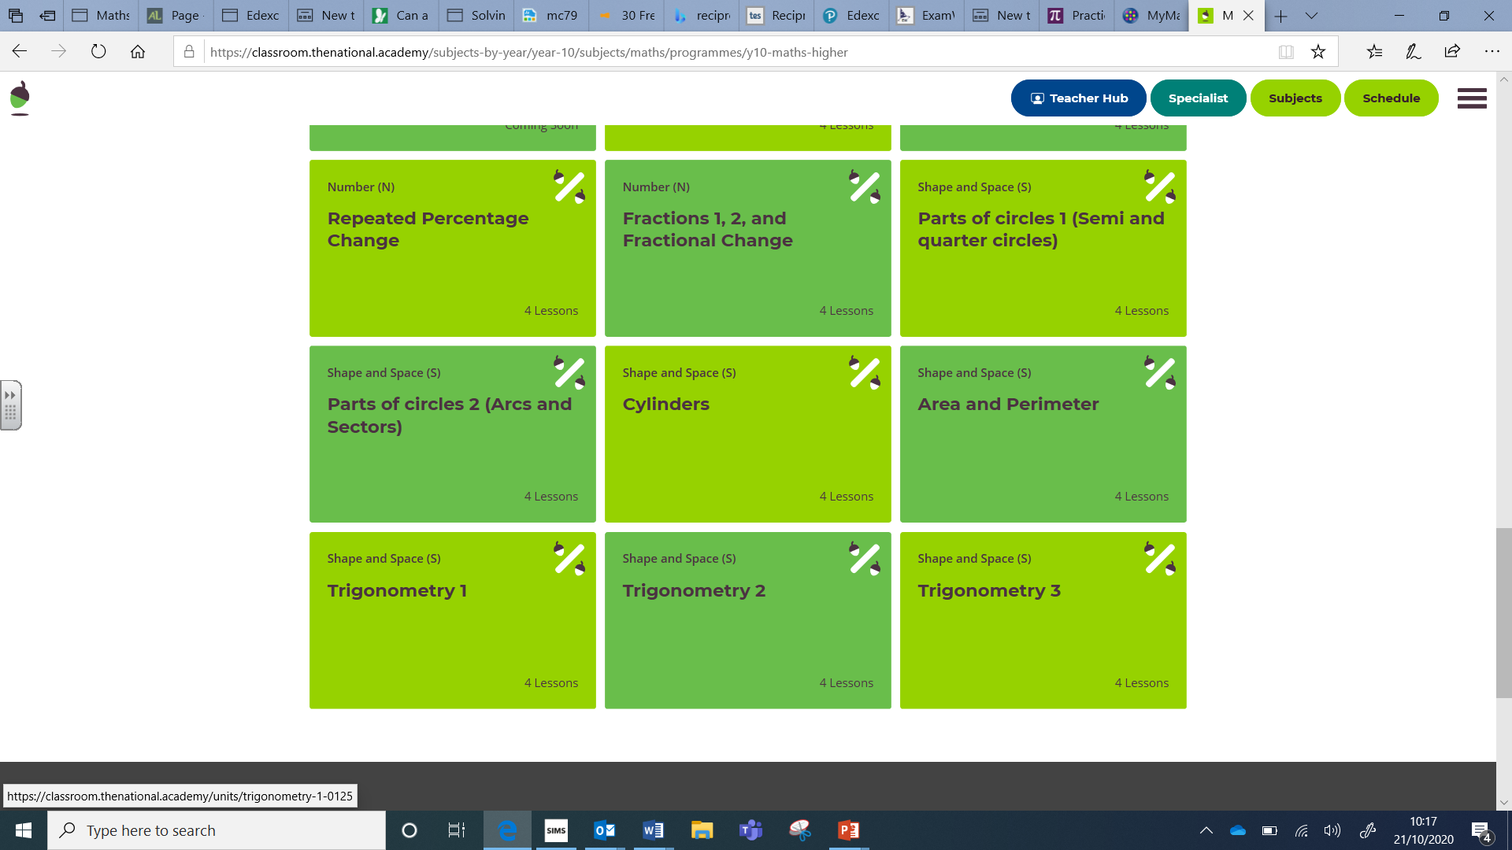

STEP 3: Click on Lesson 1 ‘Know tangent, sine and cosine’:
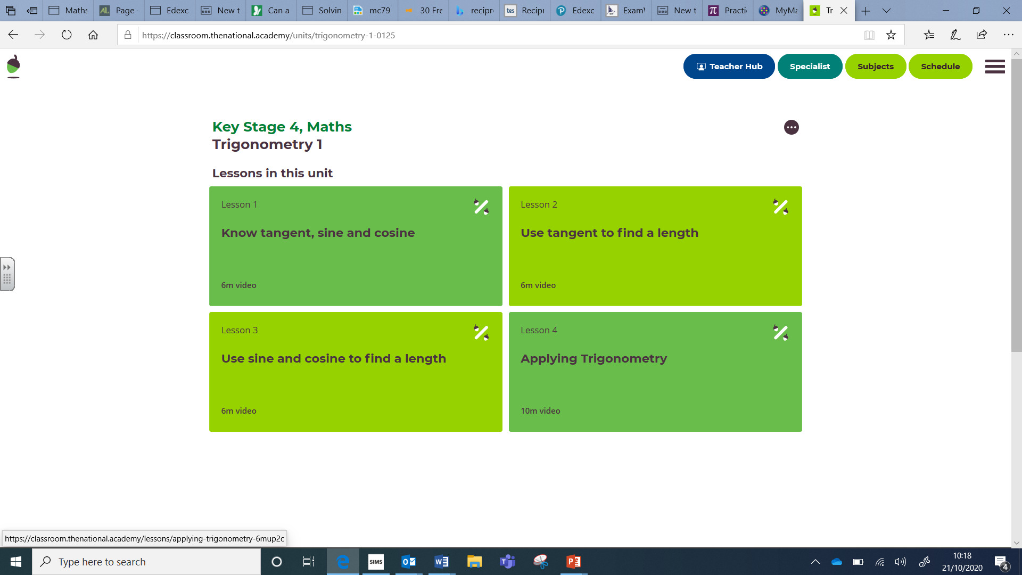

STEP 4: Click start lesson and play video
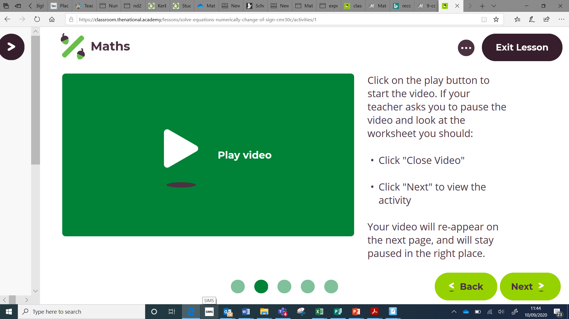

STEP 5: After watching the video, click next and work through the slides
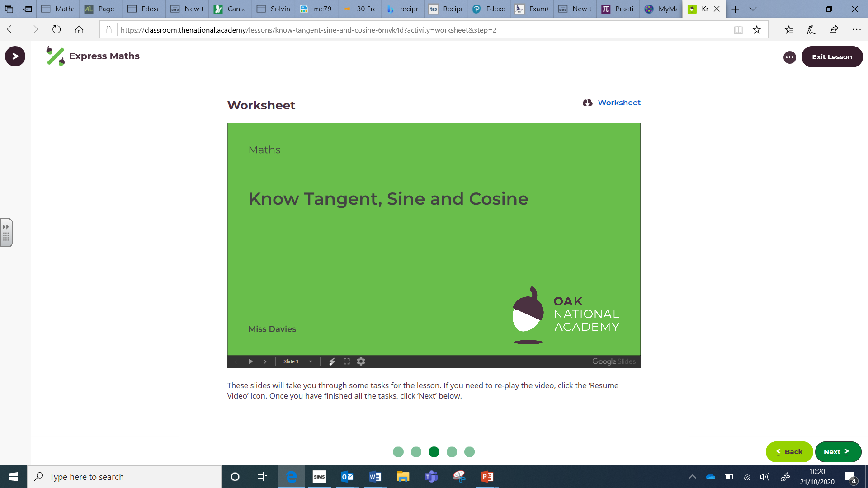

STEP 6: Complete the Final Quiz
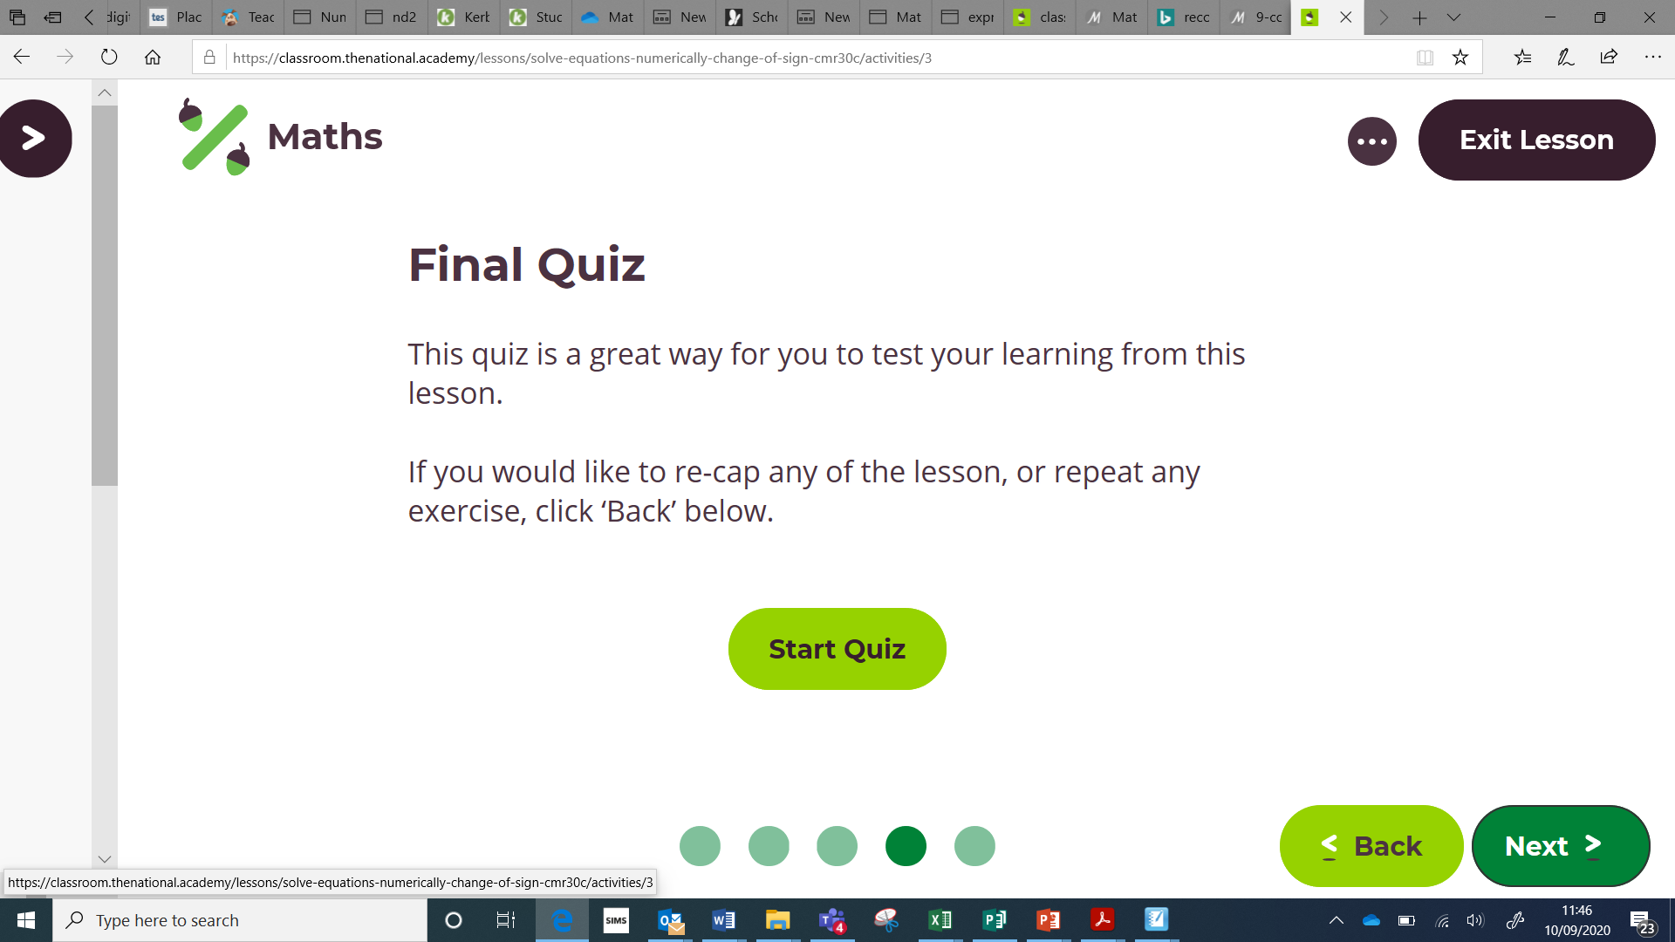

LESSON TWO
Repeat steps 1 and 2
Select lesson 2 (Use a tangent to find length then follow steps 3 to 6

LESSON THREE
Repeat steps 1 and 2
Select lesson 3 (Use sine and cosine to find length) and then follow steps 3 to 6
LESSON FOUR
Repeat steps 1 and 2
Select lesson 4 (Applying trigonometry) and follow steps 3 to 6
LESSON FIVE
Repeat step one.
Scroll down to ‘Algebraic fractions’

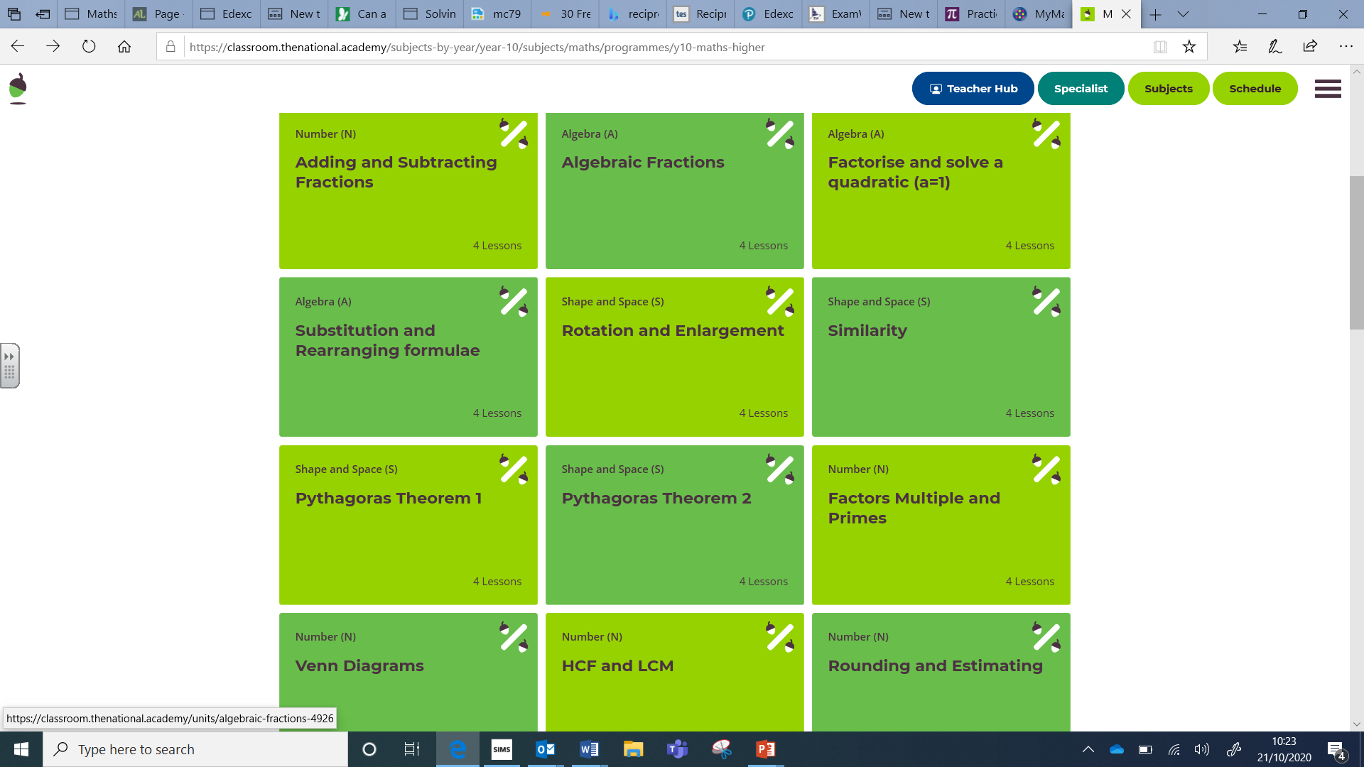
Complete Lesson 1 (Add two algebraic fractions with integer denominators)
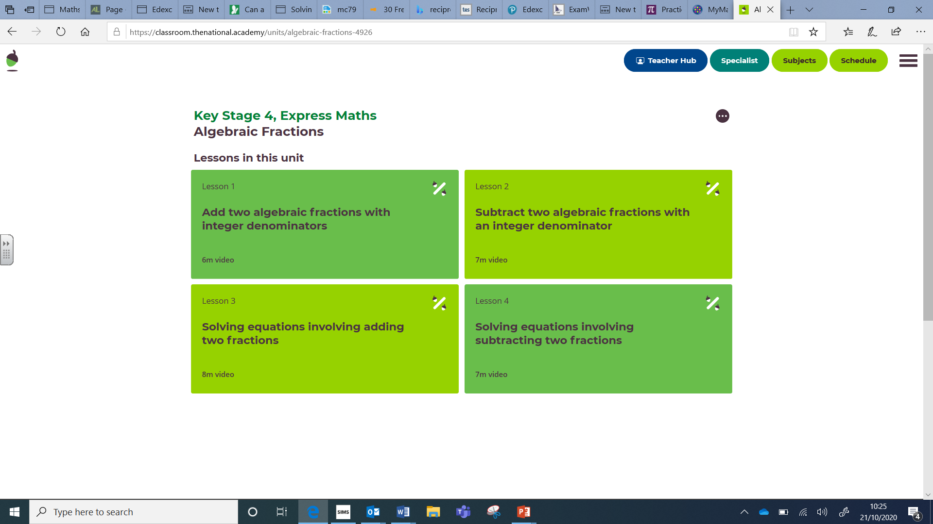
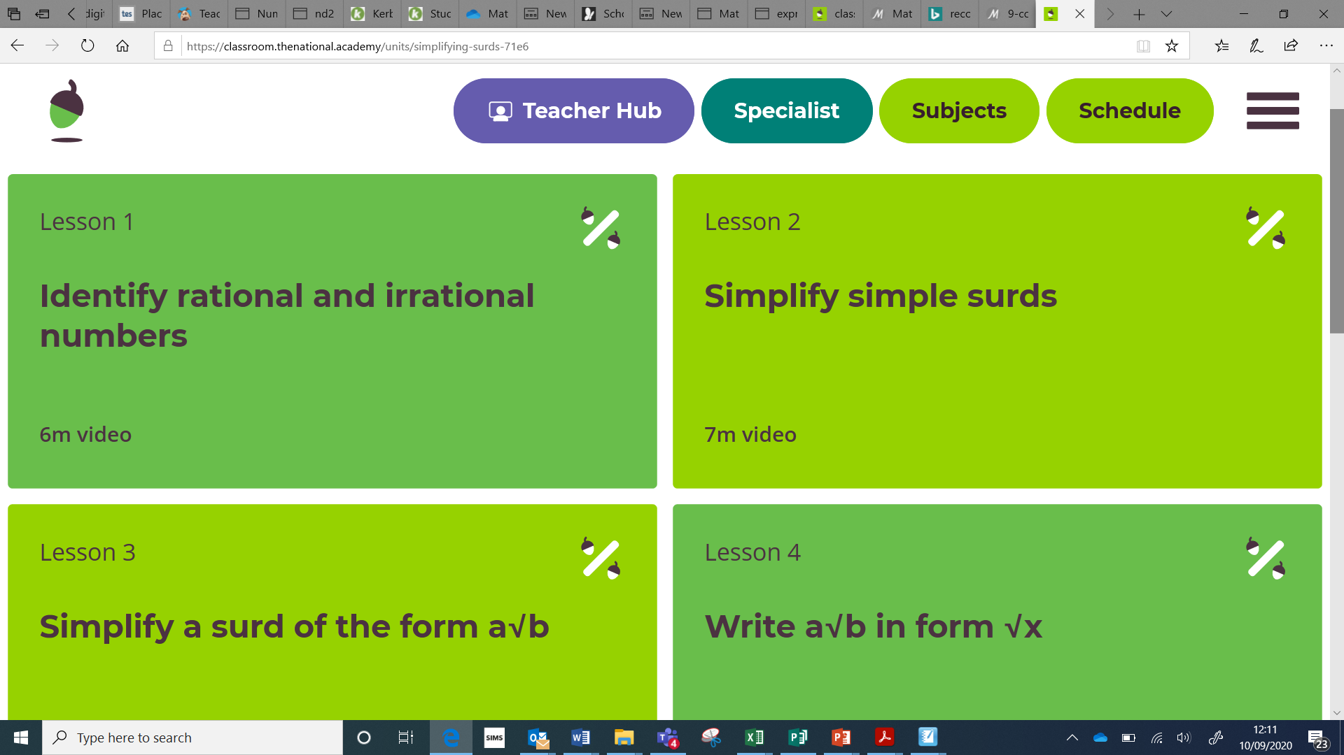

LESSON SIX
Repeat steps and complete lesson 2 (Subtract algebraic fractions with integer denominator)
LESSON SEVEN
Repeat steps and complete lesson 3 (Solving equations involving adding two fractions)
LESSON EIGHT
Repeat steps and complete lesson 4 (Solving equations involving subtracting two fractions)
LESSON NINE
Compile a revision summary in the form of a mindmap or bullet points on the two sections of work covered: Trignometry 1 and Algebraic fractions

