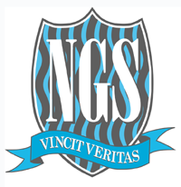

APPLICATION FORM FOR EXISTING
NEWLANDS GIRLS’ SCHOOL STUDENTS 2022

Newlands Girls’ School - Farm Road, Maidenhead, Berks SL6 5JB. Tel: 01628 625068
Website: www.newlandsgirlsschool.co.uk

Co-Headteachers: Miss J. Capon & Mr M. Henshaw Head of Sixth Form: Mrs G. Walton

If you wish to apply to the Sixth Form, please complete the application form below by Thursday 10th February 2022. Please either email your application form to Mrs Bretherton, Sixth Form Administrator at KateBretherton@newlandsgirls.co.uk or give your form to Miss Forster.

Full Name: | Form:

Current Year 11 Subjects

Subject | Grade  on last report | Subject | Grade  on last report | Subject | Grade  on last report
1. Mathematics |  | 5. |  | 9.
2. English Language |  | 6. |  | 10.
3. |  | 7. |  | 11.
4. |  | 8. |  | 12.

Proposed Sixth Form Subjects – You can choose A-Levels, BTEC subjects or a mix of both.

A-Levels / BTEC – Please give 3 subjects and 1 reserve, in order of preference.

Subject 1 | Subject 2 | Subject 3 | Reserve

Future plans (if any yet, for further education and/or career)

