TERM 5 HOME LEARNING PROJECT: SCRIPTWRITING

Year 8 Drama Work
Evacuees

Name: Form:

You can print this booklet off and complete on paper, or you can complete electronically.

LESSON ONE:

We are going to be exploring a DEVISING unit through the topic of EVACUEES.

Please watch this short video that will help you answer the following questions.

https://www.youtube.com/watch?v=G0SEAObflWQ

Questions:

- In drama, we often devise from a stimulus. What does devising mean?

- What is a stimulus?

- What could a stimulus be?

- What is another name for a storyline?

- Now please look at the link below:

https://www.bbc.co.uk/bitesize/guides/zg9x34j/revision/1

In the space below, please write some notes on what you have learned.

LESSON TWO:

Today’s lesson will focus on developing your understanding of the experience of being an evacuee. Please read the accounts and news articles on the BBC History website by following the link below:

https://www.bbc.co.uk/history/british/britain_wwtwo/evacuees_01.shtml

Now look at the image below:

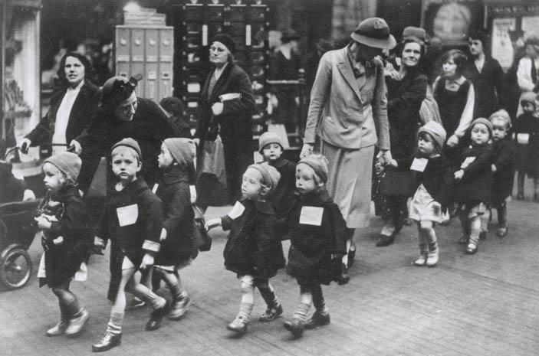

- What is happening in this picture?

- What would they be thinking and feeling?

- What was life like in the city?

- How did the city differ from life in the countryside?

- Based on your reading and the image above, brainstorm some ideas for the storyline.

LESSON THREE
Today’s lesson will be used to decide on your PLOT and CHARACTERS. Please complete the table below.

PLOT  BEGINNING: How does the play open?  MIDDLE: What happens during the piece?  ENDING: How does the piece finish? Do you want it to be a happy or sad ending? | SETTING  Where and when does the action take place?
TECHNIQUES
Describe any techniques you’d like to use.
CHARACTERS
Write a character list, with a short description of each.

You now have the outline of an idea. Create a role on the wall for two of the main characters, using the ‘gingerbread men’ below. You should include their key information (name, age, family etc), personality traits and attitudes.

LESSONS FOUR AND FIVE:

You are now ready to write your script! You can use the blank pages at the end of this booklet or start a new document. The script should contain at least three scenes and have a clear beginning, middle and end. You must give the script a title and list the characters before the action begins.

Remember to include stage directions in brackets and italics. Stage directions are instructions. They may say where a character should stand, what they are doing, who they are speaking to, how they move, speak and gesture. They will also contain information about costume and set.

For example:

The Dorset Adventure

London 1939

(Scene opens with Jack sitting centre stage on a rocking chair, he is reading a newspaper that has the headline WW2 has been declared, he slowly closes the newspaper and places it on a side table next to his rocking chair, he begins to slowly rock as he lifts his sleeve and looks at his arm. He stands up and moves down stage centre and directly address the audience)

Jack: I don’t know, it doesn’t seem any time has passed since we were at war before. I still hear the shells. My old wife, bless her, said I went to war a boy and came back a broken man. We didn’t speak of such things but now I am older, I realise a lot of us were in shell shock, we just didn’t speak of it. My grandchildren are going to the countryside to live. I am going to go with them. You see we are lucky. My sister has a house in Dorset, and we can all go and stay with her. I went once before and I must say apart from the awful smells it is peaceful. At least they are with me, my dotty – my daughter - is beside herself. Her husband is in the army and with her kids going to Dorset, she doesn’t know what to do. She is going to work in a factory. Do her duty.

(doorbell goes)

Elsie: Grandad, Grandad is it true you’re coming to aunties too? Mummy said it will be a big adventure and William said if you press a cow it is like a tap, but milk comes out!

William: no I didn’t I said that..

As you can see, the stage directions help the director and actors know what to do and how to do it. If you are stuck for an idea, you can use this script as a starting point and continue it from here.
EXTENSION TASK:

Please also consider set and costume design. Please make a note of the set design, and draw costumes for the two characters you wrote about earlier below.
DEADLINES:

Please ensure that your script, along with this booklet, is submitted to your class teacher when you return to school. The running time for your piece should be no more than 10 minutes and no less than 5. You can use family members to read aloud and help bring your work to life. It is expected that this project will take you 5 weeks.

ASSESSMENT:

We would like you to write a whole script but for assessment purposes, you must submit Scene 1 to me by Friday 22nd May. This will be marked and you will be given a drama grade. You must set out your script correctly (please follow the guidelines in your pack) and you will be marked for the creation of characters and the creativity of the potential story. Choose your language carefully and think of the period in which it is set. We understand this is only a snapshot of your whole script. Scene 1 should be no more than 2 sides of A4.

Good luck!

